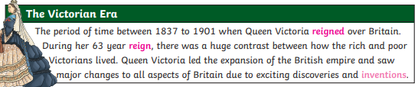
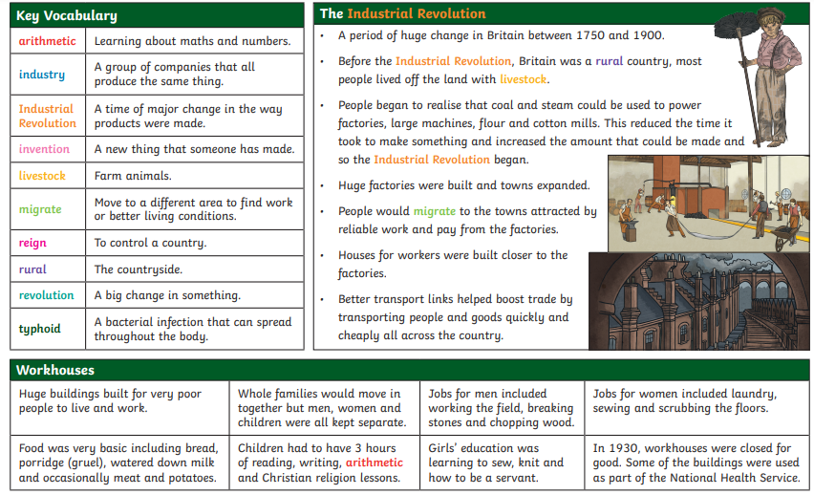
Year 5 Victorians
Knowledge Organiser

