
The Earth and Moon are
Key Vocabulary
Asteroid – A small rocky body orbiting the sun
Axis – An imaginary line about which a body rotates
Celestial – Positioned in or relating to the sky, or outer space as observed in the astronomy
Day – A twenty-four hour period, from one midnight to the next, corresponding to a rotation of the earth on its axis
Dwarf planet – A celestial body resembling a small planet but lacking certain technical criteria to be classed as a planet e.g. Pluto
Geocentric – Where people believed the earth was at the centre of the solar system
Heliocentric – Representing the sun as the centre of the solar system, the modern view of the solar system
Moon – A natural satellite of any planet
Night – The period from sunset to sunrise in each twenty-four hours
Orbit – The regularly repeated oval course of a celestial object around a star or planet
Planet – A celestial body moving in orbit round a star
Rotation – The action of rotating about an axis or centre
Solar system – The collection of eight planets and their moons in orbit round the sun
Star – A fixed luminous point in the night sky which is a large, remote body like the sun
Sun – The star round which planets orbit

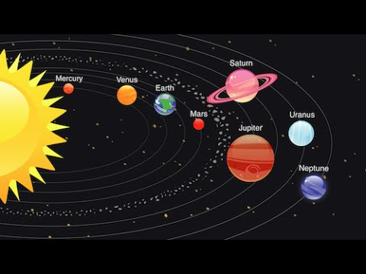
Approximate spherical
Bodies which orbit the
Sun. The Milky Way (Our
Universe) is heliocentric.
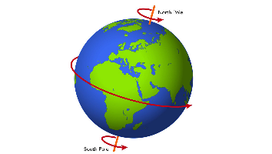

The Earth’s rotation causes
day and night
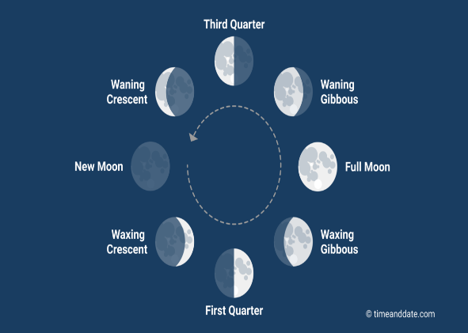
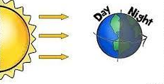

Event | Duration
Earth orbits Sun | 365 days (1 year)
Earth rotates axis | 24 hours (1 day)
Moon orbit Earth | 28 days
Mercury orbits Sun | 88 days
1 day on Mercury | 58 days 15 hours
Neptune orbits Sun | 165 years



