Eco Schools
‘Every child, every school and its community have to believe they can make a difference’.
At Saint Francis Xavier’s School we firmly hold this belief and we would like to improve and enhance our school grounds, improve our recycling and sustainability and raise awareness of our community links over the next few years.
The Eco council meets to discuss a wide range of interests and issues, such as looking at recycling in the school, sustainability, Clean for the Queen Campaign and designing and planning a new school garden and wildlife area. Our aim is to achieve the Eco Silver Award in due course.
Year 4 is linking their science topic of Habitats with The Countryside Restoration Trust. They are the UK’s leading charity promoting wild-life friendly farming. Through education the children can link food, farming and the countryside. They are also visiting Tesco’s Farm to Fork Trail to learn about Healthy Eating. The school had a competition to see which house had the cleanest plates and the least waste at lunchtime.
The school ran a competition to create an Eco Code and it was won by Maria Robles which now is displayed proudly in our foyer.
We have encouraged teachers and children to save energy by switching of whiteboards and lights and Welsh water have educated us on the importance of saving water and even replaced our taps in KS2 with push taps.
During the summer of 2016 parents and children spent a day installing a raised bed garden. This was done with support from parents and local business’ donating resources and plants. That summer we grew lettuces which we sold at our school fete to raise money for the school resources and pumpkins which we donated to The Poor Clare Monastery in the Autumn (they made some delicious soup with them).

Selling our garden produce to raise money for resources.
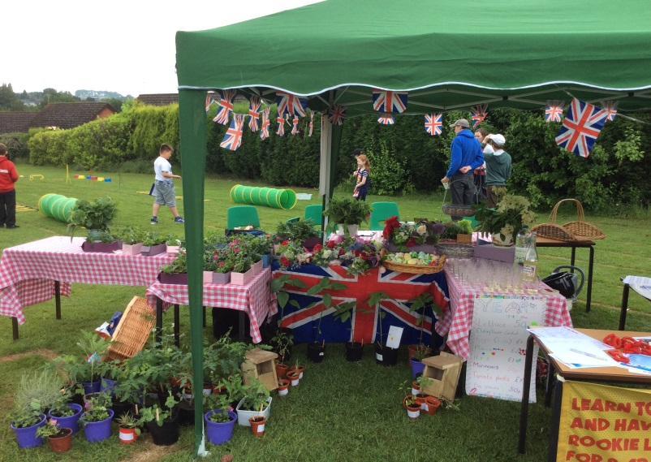

Our garden began with a few pots and a greenhouse…
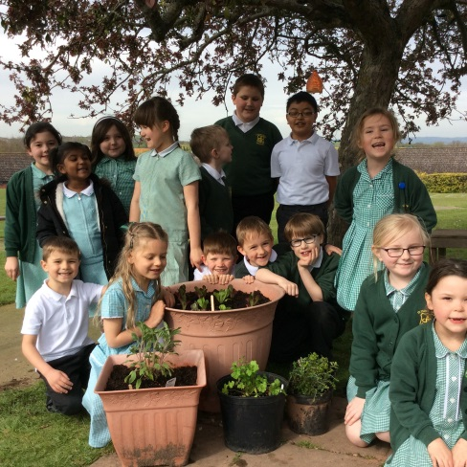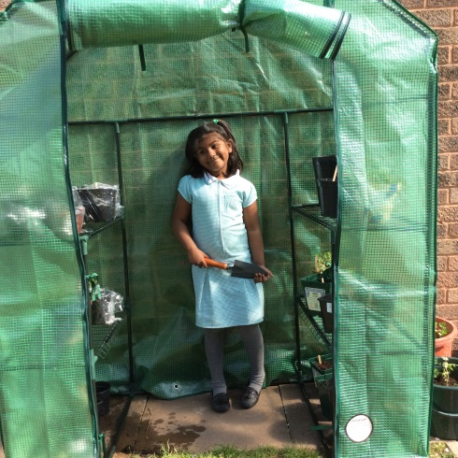
Then we had help from parents and children…
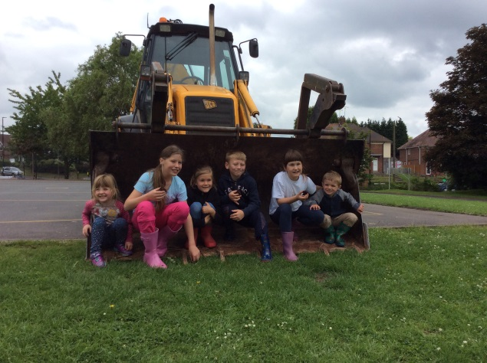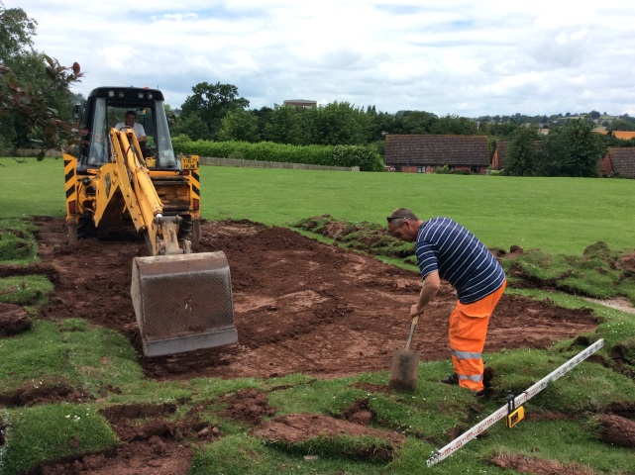

And it grew….
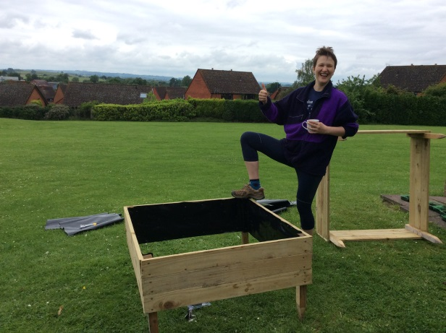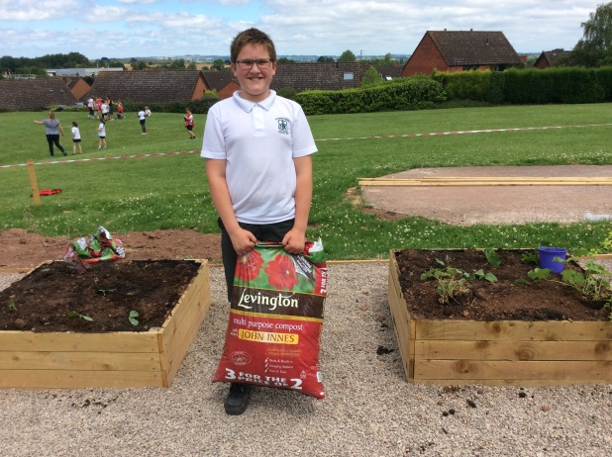

And grew….
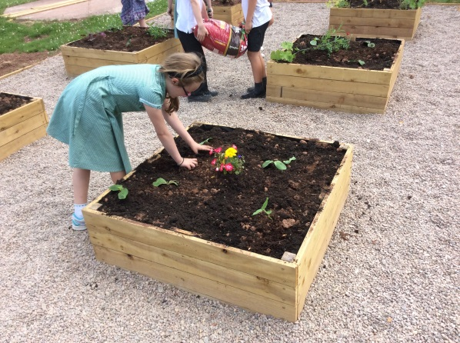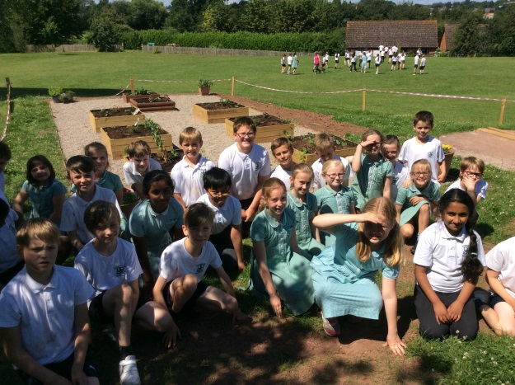
Until we had plenty of produce to share….
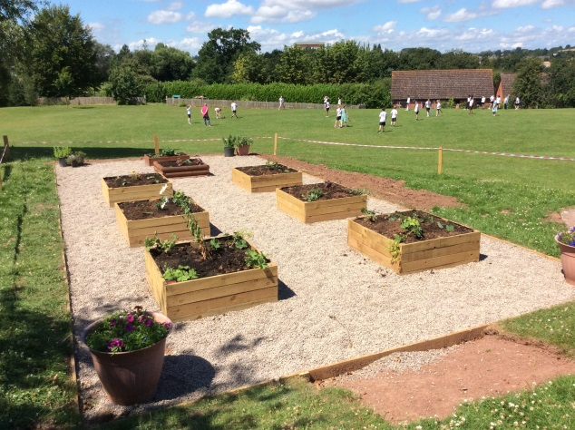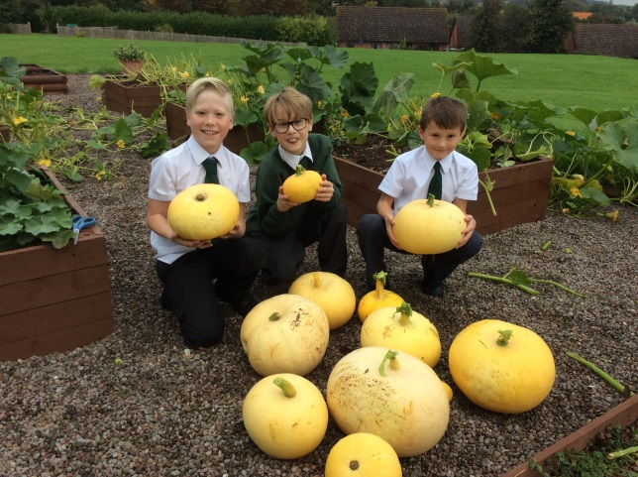

This summer we hope to attract more birds to our garden by planting a wild flower area, installing a bug hotel and making habitats suitable for hedgehogs. We are completing this in conjunction with ideas from the Royal Society for the Protection of Birds (RSPB).
We aim to make the area in to an outdoor classroom with wooden seating so children can be taught in a more cross-curricular way learning about science, maths and literacy in the garden.
Our Eco council presented an assembly to educate the whole school about being environmentally aware and Jane Denny (Herefordshire Eco Lead) came to deliver an informative assembly about litter.
If you would like to support our projects please contact Mrs S George (Year 4). It is lovely to have so much support from parents in the school which helps us to support our community links.

