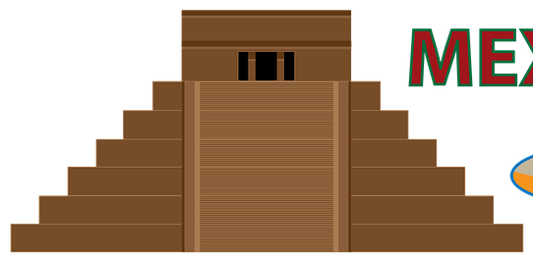
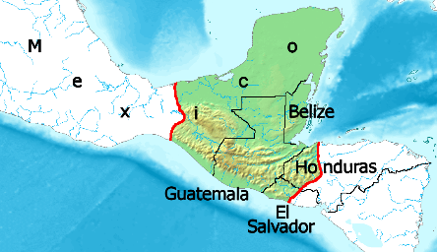
Central
America
Mayan Civilization

 | Key Vocabulary
astronomy | The Mayans were able to predict solar eclipses and used observatories and shadow-casting devices.
calendar | These were circular and charted the movements of the sun, moon, stars and planets, with 365 days in a year.
hieroglyphs | They used about 800 symbols to create writing, often on folded pages forming a book (codex).
Kings/Queens | The King/Queen was thought to be given the right to rule by the gods. Each city had a palace for them.
maize | The staple food of the Mayans which was so important that they even had a maize god.
numbers | Using a base 20 system (we use base 10), they used dots and bars to create numbers and had a symbol for zero.
pok-a-tok | A game where large rubber balls were aimed at stone hoops. Losers were sometimes sacrificed to the gods!
pyramids | Built with a temple at the top to give sacrifices to the gods, others were built for the gods themselves.
sacrifice | Humans and animals were used as a blood offering to gods, mostly war prisoners by decapitation or heart removal.
stelae | Stone monuments glorifying Kings and record his deeds, although early examples were of mythical scenes.
Timeline
1100 B.C. | 800 B.C. | 400 B.C. | 300 B.C. | 100 B.C. | 600 | 800 | 900 | 1502
The first hunter-gatherers settle on the pacific coast | Village farming and trade become established | First solar calendars invented | Cities become centres for trade and Kings begin to rule | First pyramids are built | Cities start expanding quickly | Building of stepped pyramid of Chichen-Itza | Decline of Mayan cities | First contact with Europeans is made

Mayan Gods
Some were in human form, others in animal but the most supreme god was Itzamna, the creator god, lord of day and night and ruler of the heavens. Many looked after the weather or crops such as Chac, the rain god and Kinich-Ahau the sun god. Priests would perform ceremonies (including sacrifices) to please them and Kings were thought to turn into gods after they died. They believed the world was divided into three parts (Heaven, Earth and the Underworld), linked together by a giant world tree.

Palenque Rulers
Archaeologists can name 17 rulers of the city-state of Palenque from 431-800. The most famous was Pakal I, also known as Pakal the Great, who ruled from 615-683. He began his rule at the age of just 12 and constructed some of Palenque’s finest buildings and founded a great dynasty. His funeral mask was carved from stunning Jade.

Mayan Dress
Commoners and slaves wore plain loincloths, but the elite added feathers, animal skins or gems. Noblemen covered their lower half with a colourful garment and wore large, elaborate headdresses. Women wore skirts and tunics. Footwear was simple, usually being barefoot or sandals.

Trade
Merchants drove their human caravans along roads, down rivers and around coasts to trade with fellow Mayans and other Mesoamericans. The geography was so varied that they relied on trade to get the things they needed off each other, from maize, fish and salt to stingray spines (used for bloodletting) and valuable stones such as jade and obsidian.

What happened to the Mayans?
Around 900, many cities in the southern lowlands were abandoned but states in the uplands of the Yucatan peninsula continued to flourish until the arrival of the Spanish in 1502. One belief is that the Toltecs and the Aztecs took over with their own empires but later, when the Spanish arrived, they brought disease and forced them to give up their gods and become Christians.
General Knowledge
Famous Figures

The Mayans tied boards to their babies' heads to produce a flat forehead. They also tried to make their babies cross-eyed! Big noses were also considered beautiful.

