 | Creation and Covenant | Assessment
C&C3.1 | I can remember and recall the Creation passage and am able to order the days. I know where the passage is found and who wrote it.
C&C3.2 | I can recognise that Sunday is a holy day for Christians and make links between the story of Creation (Gen 1:1-2:4) and Sunday as a day of rest.
C&C3.3 | I can describe how a psalm I have studied praises creation.
C&C3.4 | I can retell the story of Abraham
C&C3.5 | I can explain and show understanding of the meaning of Covenant linked to Abraham and his decisions.
C&C6 | I can illustrate the role of Abraham in Judaism and Christianity.
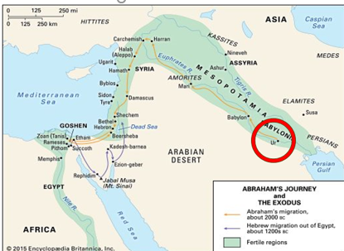
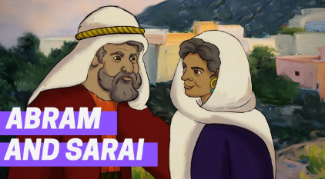
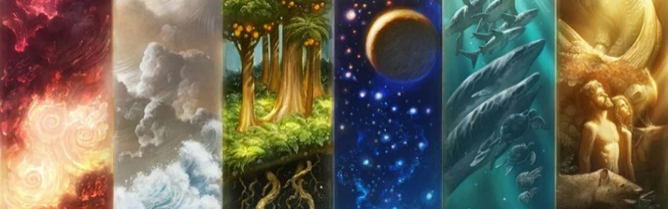
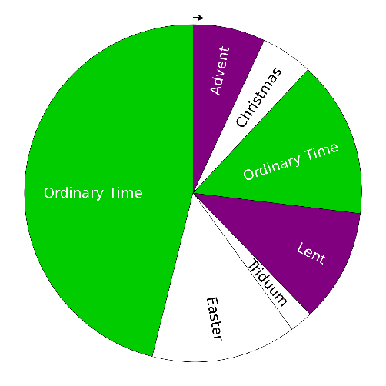
²⁶ Then God said, “Let us make mankind in our image, in our likeness, so that they may rule over the fish in the sea and the birds in the sky, over the livestock and all the wild animals,^{[a]} and over all the creatures that move along the ground.”
²⁷ So God created mankind in his own image,
in the image of God he created them;
male and female he created them.

Extract from Genesis 1: 1:1

Year C - Branch 1
Creation and Covenant
Year 3
Key vocabulary:
Genesis
Creator
Image and likeness
dignity
equality
Abraham
Covenant
Israelites

