Regions of England
North East
Yorkshire and Humberside
East Midlands
East Anglia
South East
South West
West Midlands
North West
Physical geographical features in England
Rivers:

River Thames
River Severn
River Wye
Hills & Mountains:

The Peak District
The Black Mountains
The Brecon Beacons
The Malvern Hills
Coastal features:

The Bristol Channel
The English Channel
Land’s End
Gower Peninsula
Pembrokeshire Coast
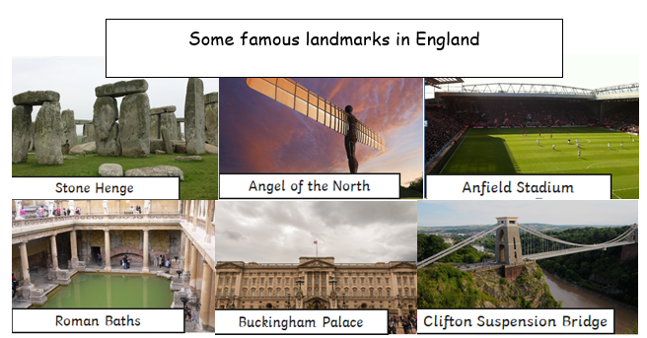

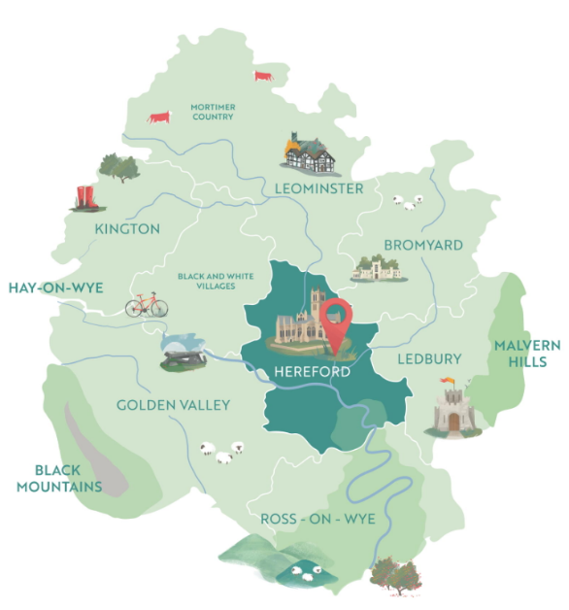
Some of the main cities in England
Assessment:
To name and locate counties and cities in the UK
To name and locate the geographical regions and their identifying human and physical characteristics
To identify the key topographical features of the regions including hills, mountains, coasts, rivers and land-use patterns.


