Year 3 – Art & Design: Autumn Term (Drawing)
LO: To draw Stone Age animals using different media to achieve variations in line, texture, tone and shape.
Key Vocabulary
line | A line is an identifiable path created by a point moving in space. It is one-dimensional and can vary in width, direction, and length. Lines often define the edges of a form. Lines can be horizontal, vertical, or diagonal, straight or curved, thick or thin.
texture | Artists use texture to add depth, interest or balance to different areas of their drawing. It gives the illusion of a textured surface created through changes in mark making.
tone | Tone describes the lightness or darkness of an object that is drawn.
shape | Shape is a flat area surrounded by edges or an outline. Artists use all kinds of shapes. Geometric shapes are precise and regular, like squares, rectangles, and triangles. ... Biomorphic shapes are often rounded and irregular, unlike most geometric shapes.
Charcoal | Black crumbly material made of carbon, often used for sketching and under-drawing for paintings. Charcoal smudges easily.

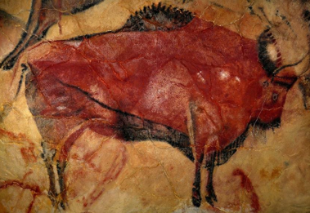
Assessment Criteria | W, MA, A, GD
Experiment with different medium eg; charcoal for drawing, berries, mud, oil
Plan, refine and alter drawings
Use sketchbook to collect and record visual information from different sources.
Draw for a sustained period of time at own level.
Use different media eg: charcoal to achieve variations in line, texture, tone, colour, shape and pattern.

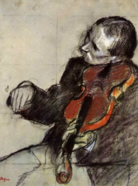
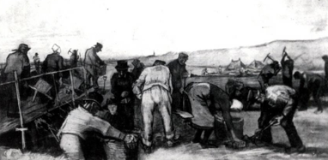
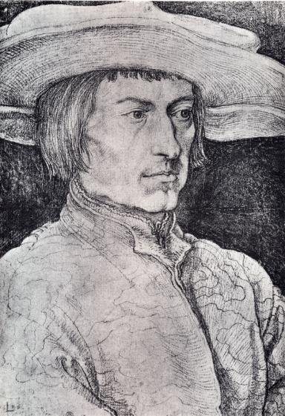
A replica of 14,000 year old picture of a bison in Altamira Cave, Spain
Various drawings using charcoal by artists Albrecht Dürer (1521), and Vincent Van Gogh (1883) and Edgar Degas (1878)

