Features of a canal
Navigable aquaducts – bridge structures that carry navigable waterway canals over rivers, valleys, railways or roads. | 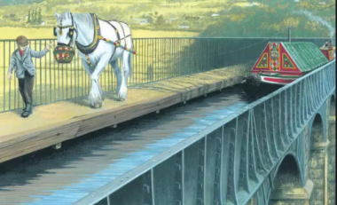
Locks – canal locks are the way in which canals can go up and over hills by altering the water level of the canal. | 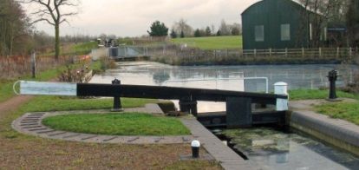
Bridges – were built to carry paths and roads over the canals and to enable farmers to access their livestock and crops on land that had been divided when the canal was built. | 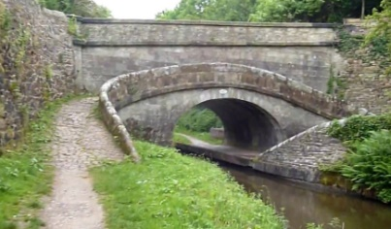
Weirs – help to remove excess water and maintains appropriate water levels. | 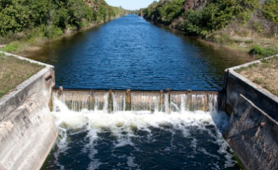
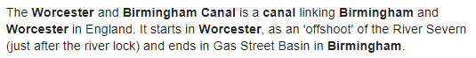
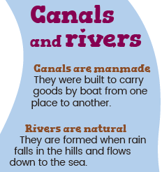
Year 3 - Geography Knowledge Organiser: Canals
To know the difference between a river and a canal.
To identify a variety of features of a canal
To understand meaning and uses of a topographical map.
To understand what raw materials were sourced in the midlands and how they were transported
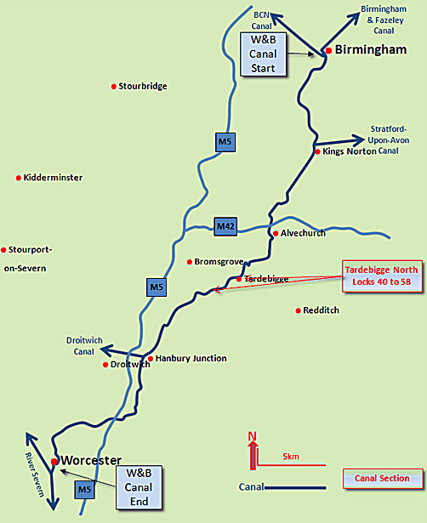
Tardebigge Locks is the longest flight of locks in the UK, made up of 30 narrow locks on a 2 and a quarter mile stretch (3.6km) of the Worcester to Birmingham Canal at Tardebigge, Worcestershire. It raises the waterway 67m and lies between the Tardebigge Tunnel (530 metres long) to the North and the Stoke Prior flight of six narrow locks to the South.

