Year 3: Knowledge Organiser - History of British Waterways - the Canals
Assessment of Knowledge:
What is a canal? Why they were built?
Who built the canals?
To how canal boats were built and what materials were used.
Changes over time in waterways
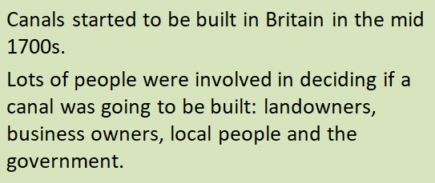
Canals were built to connect the United Kingdom. As a transportation system, the waterways allowed goods to be transported with ease. Before there were cars trains and planes, the most efficient way of transporting goods was via the waterways. There were horse-drawn carts, but boats were quicker and could carry more.

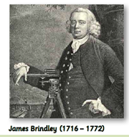
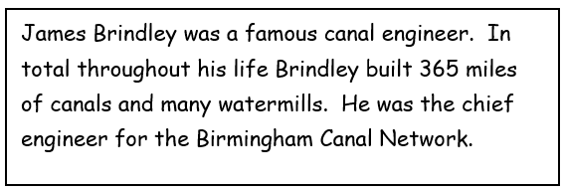
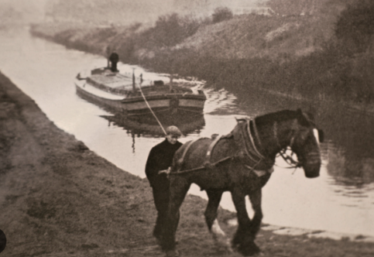
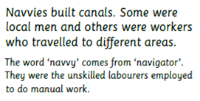
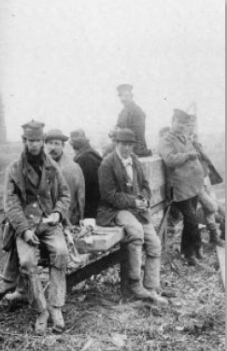
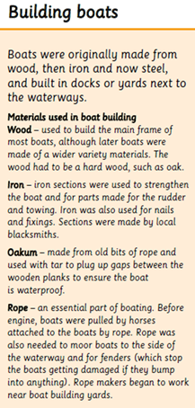
Key Vocabulary:
Canal
Navvies
Engineers
Transportation
Tow path
Industry
ports

Horses pulled canal boats along the tow path

