Year 3: Spring Term Knowledge Organiser - Canal Folk Art
LO: To use a range of effects and textures to create a Roses and Castles bookmark
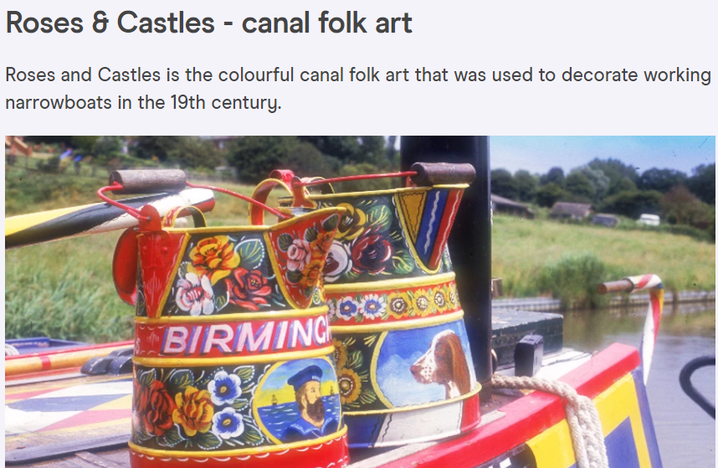
Skills | Assessment
Mix a variety of colours
Know which primary colours make secondary colours
Use a developed colour vocabulary
Experiment with different effects and textures including blocking in colour, washes and thickened paint
Work confidently on a range of scales eg: thin brush on small picture



