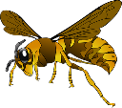
The 7 Levels of Classification

Today we use 7 different levels of classification. These are as follows:

Kingdom (Keeping)
Phylum (Precious)
Class (Creatures)
Order (Organised)
Family (For)
Genus (Grumpy)
Species (scientists)

Here is an example of how humans are classified. You will see that our species is homo sapiens.

Kingdom: Animalia
Phylum: Chordata
Class: Mammalia
Order: Primates
Family: Hominidae
Genus: Homo
Species: Homo sapiens

Living Things and their Habitats
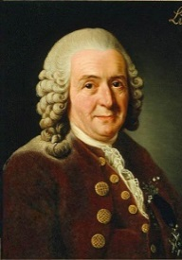
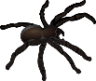
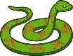
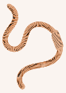
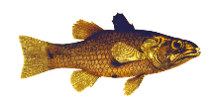
Carl Linnaeus then simplified the naming of living things in 1735. Names of living things were often very long so he gave them a two-part (binomial) name. It was a mixture of genus and species (and in Latin) e.g. Human was Homo Sapien, Wolf was Canus Lupus and Lion was Felis Leo.
In about 350 B.C. Aristotle (a Greek philosopher) classified all things into 4 main groups.
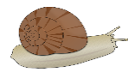
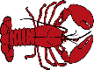

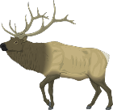
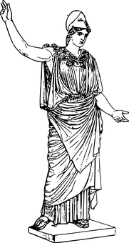
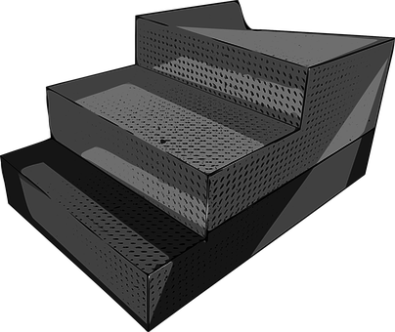
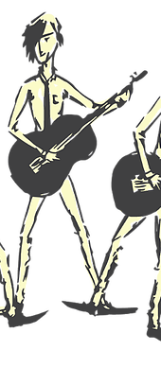
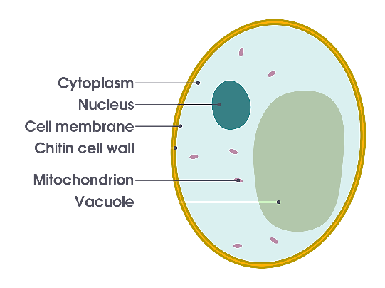
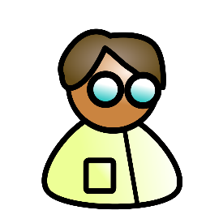
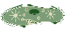

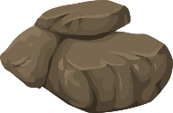

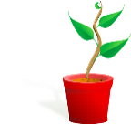

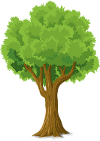
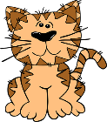
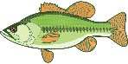
Vertebrates (backbone)

Invertebrates (no backbone)
3 Types
- Viruses
- Bacteria
- Fungus

1.) In complex organisms, groups of cells form tissues (for example: in animals, skin tissue or muscle tissue; in plants, the skin of an onion or the bark of a tree).
2.) Tissues with similar functions form organs (for example: in some animals, the heart, stomach, or brain; in some plants, the root or flower).
3.) In complex organisms, organs work together in a system (the digestive, circulatory, and respiratory systems).

Microorganisms
If you can only see a living thing with a microscope, it means it is a microorganism. These are found everywhere. Some of them, like yeast are helpful whilst some of them are harmful and disease causing, like bacteria. It is important to know how to avoid spreading the bad ones. (Wash your hands!)

Kingdoms
Scientists have now divided living
things into five larger
groups called Kingdoms.

1.) Plants
2.) Animals
3.) Fungus (mushrooms, yeast, mould, mildew)
4.) Protist (protozoans, amoeba, euglena)
5.) Prokaryote (blue-green algae, bacteria)
Yeast (microorganism)
Human Beings
Plants (trees and grass)
Animals (cats and fish)
Non-Living (rocks)

