A region of France: Franche- Comte
 |  | Key Vocabulary
citadel | A fortress, high above the city.
Tourist attraction | A place or landmark which visitors to a region enjoy.
population | How many people live in a region
pedestrianised | An area designated for pedestrians with no vehicles.
historic | Ancient, full of history
architecture | The style of building which dates from a certain era or is built in a particular style.
region | An area of France
topography | Facts and data about the climate and physical geography.
produce | The food an area makes using local ingredients.
industry | The way people in an area make money.
UNESCO heritage site  DID YOU KNOW? | A world renowned area of particular interest to our heritage
Information about Franche-Comte
Nearby Cities: Belfort, Dijon, Lausanne
Besancon is on the route between Strasbourg and Lyon.
The ancient city of Besancon is one of the best preserved historic cities in France.
Famous Landmarks

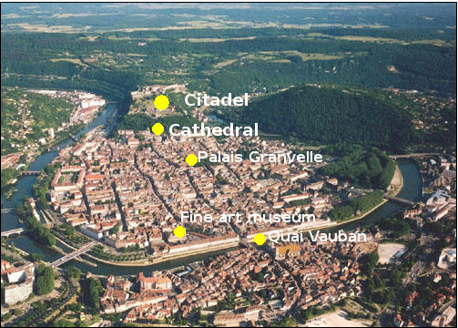Besancon is the capital of the Franche-Comte region and has a host of historic tourist attractions including:
- Vauban’s Citadel
- Historic City Centre
- Musee des Beaux Arts
- Palais Granvelle, the birthplace of Victor Hugo.


