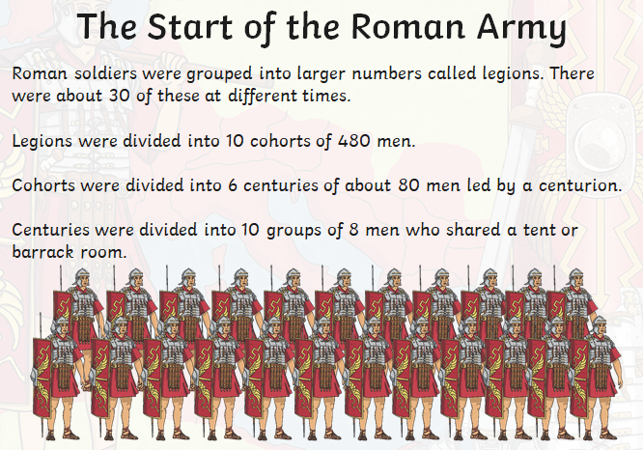
Who was Boudicca?
Boudicca was a Celtic queen who led a rebellion against the Roman occupation of Britain. Although her campaign was initially successful, her forces were defeated at the Battle of Watling Street in 61 AD.

Assessment:
To know the Romans invaded Britain
To know why the Romans invaded Britain
To know who Julius Caesar was
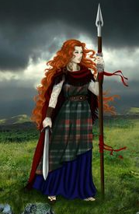
To know some of the legacies left by the Romans and
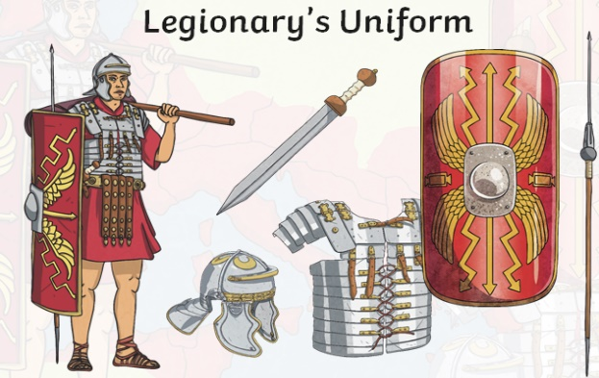
and their invasion of Britain
To know the Celts occupied Britain and be able
to describe their lifestyle
To know who Boudicca was and explain
Some of things the Romans introduced to Britain?
- Brick buildings
- Central heating
- Straight roads
- Christianity
- Reading and Writing
- Measuring distances
- Roman numerals
- Clocks
- Coins
her encounter with the Romans


