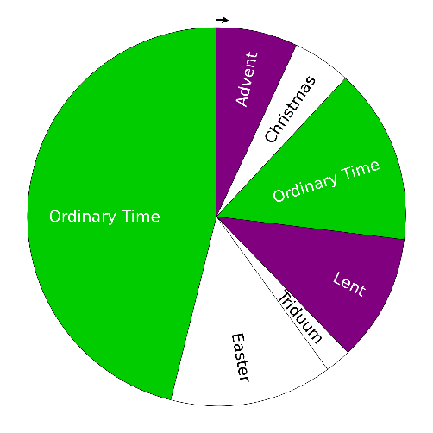
Year 3
Branch 1: Creation and Covenant (Liturgical Year B)

Key Vocabulary
Creator
Creation
Genesis
Poetry
Made in God’s image
Human dignity
Laudato Si’
Stewards
St Francis of Assisi
Common Good
Good Samaritan
Catholic Social Teaching

RED linked lesson outcomes: | WT | A | GD
U3.1.1 Revisit and remember the first Creation story from Genesis, recognising the author’s use of poetic language to describe how the world was formed.
U3.1.5 Using some religious vocabulary, describe how either a psalm or a prayer they have studied praises Creation.
U3.1.2 Encounter the belief that humans are ‘made in the image of God’ (Gen 1:27) and talk about what this might mean.
U3.1.3 Make simple links between the first Creation story, the belief that all human beings are created equal, and an expression of the principle of Catholic Social Teaching about Human dignity.
U3.1.4 Describe stewardship by making simple links between
Gen 1: 26-31 and people’s actions today.
U3.1.6 Recognise that in Laudato Si’, Pope Francis teaches that human beings are called to have a loving relationship with God, with each other and with the world.



