22
The U.K. and The Midlands
 |  | Key Vocabulary
Physical Geography | The Physical Geography of a country or region is the natural features that are there without human intervention, eg rivers, mountains, hills, lakes etc
Human Geography | The economic environmental and social impact of people on the earth. This includes population, trade, industry and settlements.
Relief | Relief is how high the land surface is, or how flat or steep
census | When a detailed study of population takes place
population | How many people live in an area
settlement | A place where people live eg a town city or village
urban | Buildings in towns and cities
rural | Mainly countryside
conurbation | Where areas of different towns or cities have merged.
transport | How people move from place to place
trade and industry | What people buy sell or make in their area
1536 and 1543 | 1707 | 1801 | 1922
Act of union between Wales and England | Parliaments of Scotland and England and Wales pass Act of Union to become Kingdom of Great Britain | Acts of Union between Kingdom of Great Britain and Kingdom of Ireland to form The United Kingdom of Great Britain and Ireland. | Most of Ireland became an independent country (only Northern Ireland did not) The United Kingdom of Great Britain and Northern Ireland
DID YOU KNOW?
General Knowledge

Hereford’s main industry is cider production.
Counties of England
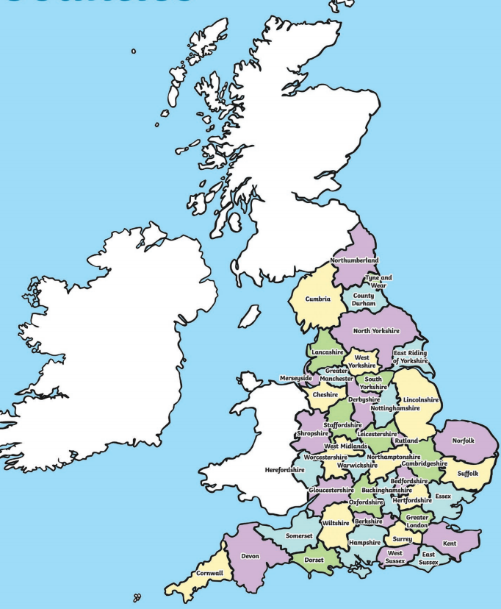
A general election in the United Kingdom is when we vote for the 650 MPs who make up the U.K. Parliament. An M.P. is a Member of Parliament and Parliament is the name of the place that our M.P.s go to in London to run the United Kingdom.

The United Kingdom is made up of Wales, Scotland, Northern Ireland and England.

Ben Nevis the the highest mountain in the UK standing at 1345m above sea level in the Scottish highlands near to the town of Fort William.

The river Severn is the longest river in the UK at 220 miles long. It passes through the West Midlands.

Staffordshire is known for the potteries industry and has many urban conurbations.
There are five areas of outstanding natural beauty in the West Midlands. These include
The Wye Valley The Shropshire Hills, Cannock Chase, The Malvern Hills and The Cotswolds.
https://en.wikipedia.org/wiki/West_Midlands_(region)#Herefordshire

