Key Vocabulary
Rosary | Rosary beads
Galilee | Jerusalem
Moses | Elijah
Disciples | Crucifixion
Resurrection | Zacchaeus
Nazareth | Israelites
Transfiguration | Parables
Jericho | Pharisees
Content area 1:  More about Mary | Mary is honoured as a key figure in salvation history. She brought Jesus into the world and is remembered as one of his disciples.  - Rosary beads  - Hail Mary prayer
Content area 2: Around Galilee | Jesus moves from place to place. In Galilee, Jesus gathers his disciples and begins bringing the kingdom of God to the world.
Content area 3: From Galilee to Jerusalem: Zacchaeus | Jesus journeys to Jerusalem, on his way teaching and instructing his disciples.  In Jerusalem, Jesus is crucified and resurrected.  Zacchaeus was a tax collector in Jericho who cheated people to get rich, but when he met Jesus, he climbed a tree to see Him and he welcomed Jesus into his home. Zacchaeus changed his ways, gave to the poor, paid back what he owed, and showed that it’s never too late to do the right thing and be loved by God.
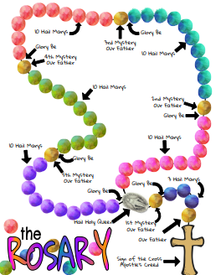
Galilee to Jerusalem
Spring 1 Year C, the Year of Luke


